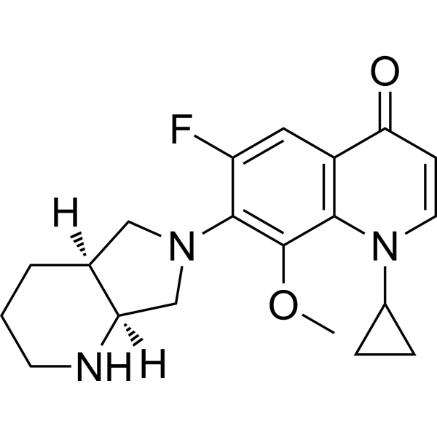

Moxifloxacin

**S01AE07 J01MA14**